REGIONAL EQUESTRIAN LEAGUE 2018-19 : GRADE III & NOVICE
Table : A

Height :

Gde-III = 1.05/1.20m
Novice = 0.95/1.10m

Speed : 325 m/min

Length : 430m

Time Allowed : 80 Sec

Time Limit : 160 Sec

Obstacles :

1 to 11
Efforts 13

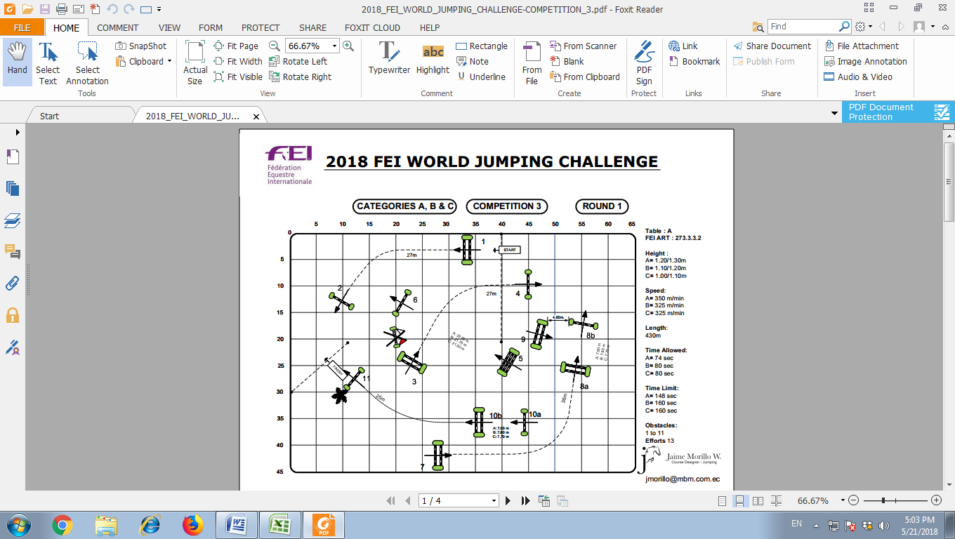
24.50m
35m
28m
28m
Gde III – 21.50m
Novice -21.00m
Gde III – 7.60m
Novice -7.50m
Gde III – 7.70m
Novice -7.60m
REGIONAL EQUESTRIAN LEAGUE 2018-19
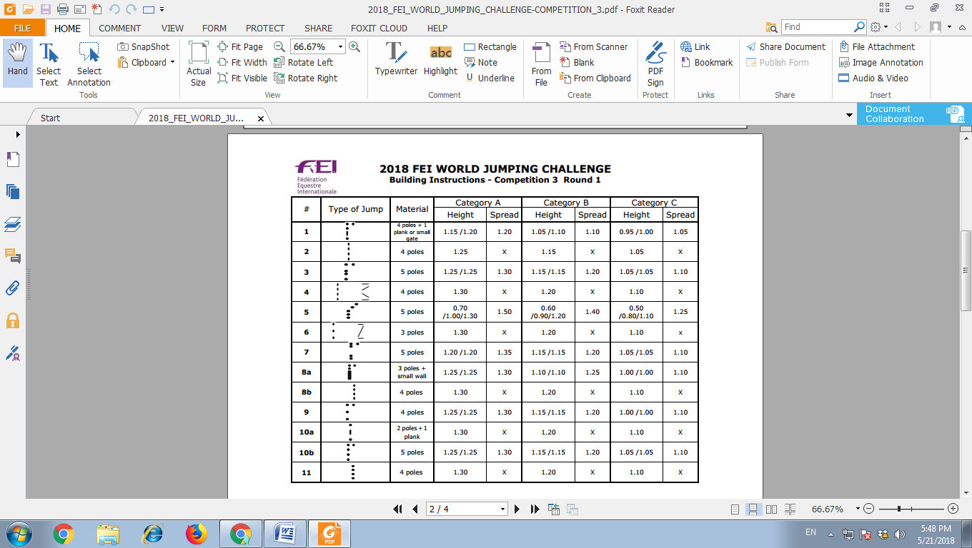 | Grade-III |  | Novice
 | Height | Spread | Height | Spread
 | 1.05/1.10 | 1.10 | 0.95/1.00 | 1.05
 | 1.15 | X | 1.05 | X
 | 1.15/1.15 | 1.20 | 1.05/1.05 | 1.10
 | 1.20 | X | 1.10 | X
 | 0.60/0.90/  1.20 | 1.40 | 0.50/0.80 /1.10 | 1.25
 | 1.20 | X | 1.10 | X
 | 1.15/1.15 | 1.20 | 1.05/1.05 | 1.10
 | 1.10/1.10 | 1.25 | 1.00/1.00 | 1.10
 | 1.20 | X | 1.10 | X
 | 1.15/1.15 | 1.20 | 1.00/1.00 | 1.10
 | 1.20 | X | 1.10 | X
 | 1.15/1.15 | 1.20 | 1.05/1.05 | 1.10
 | 1.20 | X | 1.10 | X
REGIONAL EQUESTRIAN LEAGUE 2018 : JNEC
Jump | Type | Junior |  | Children-I |  | Children-II |  | Obstacle’s  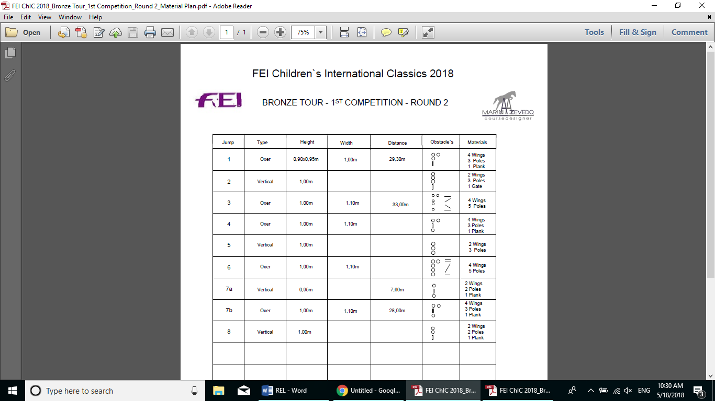 | Materials
Jump | Type | Height | Spread | Height | Spread | Height | Spread |  | Materials
1 | Oxer | 0.90x0.95m | 1.00m | 0.70m | 0.95m | 0.60m | 0.90m
2 | Vertical | 0.95m | X | 0.75m | X | 0.65m | X
3 | Oxer | 0.95m | 1.10m | 0.80m | 1.00m | 0.70m | 0.90m
4 | Oxer | 1.00m | 1.10m | 0.85m | 1.00m | 0.75m | 0.90m
5 | Vertical | 1.00m | X | 0.85m | X | 0.75m | X
6 | Oxer | 1.00m | 1.10m | 0.85m | 1.00m | 0.75m | 0.90m
7a | Vertical | 0.95m | X | 0.85m | X | 0.75m | X
7b | Oxer | 1.00m | 1.10m | 0.85m | 1.00m | 0.75m | 0.90m
8 | Vertical | 1.00m | X | 0.85m | X | 0.75m | X

REGIONAL EQUESTRIAN LEAGUE 2018-19: JNEC
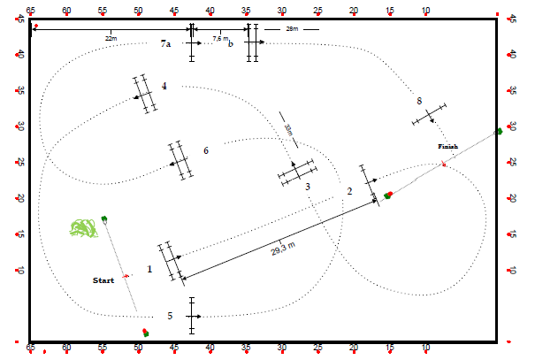
32m
7.30m

28.0m
Table : A

Height :

Junior = 0.90/1.00m
Ch-I = 0.70/0.85m
Ch-II = 0.60/0.75m

Speed : 325m/min

Length : 320m

Time Allowed : 59 Sec

Time Limit : 118 Sec

Obstacles : 8
Efforts : 9

